Set 6 Product Sales Analysis
Question 1: Grouped Bar Chart
Code:
sales <- data.frame(
Product = c("Product A", "Product B", "Product C"),
January = c(2000,1500,1200),
February = c(2200,1800,1400),
March = c(2400,1600,1100)
)
data <- rbind(sales$January, sales$February, sales$March)
barplot(data,
beside = TRUE,
names.arg = sales$Product,
col = c("red","blue","green"),
main = "Quarter 1 Product Sales",
xlab = "Products",
ylab = "Sales",
legend.text = c("January","February","March"))
Output:
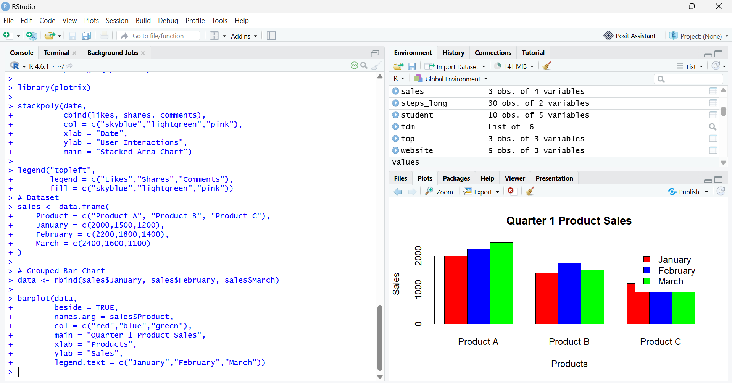

Question 2: Stacked Area Chart
Code:
months <- c(1,2,3)
A <- c(2000,2200,2400)
B <- c(1500,1800,1600)
C <- c(1200,1400,1100)
library(plotrix)
stackpoly(months,
cbind(A,B,C),
col = c("red","blue","green"),
xlab = "Month",
ylab = "Sales",
main = "Overall Sales Trend")
axis(1, at = months, labels = c("January","February","March"))
legend("topleft",
legend = c("Product A","Product B","Product C"),
fill = c("red","blue","green"))

Output:
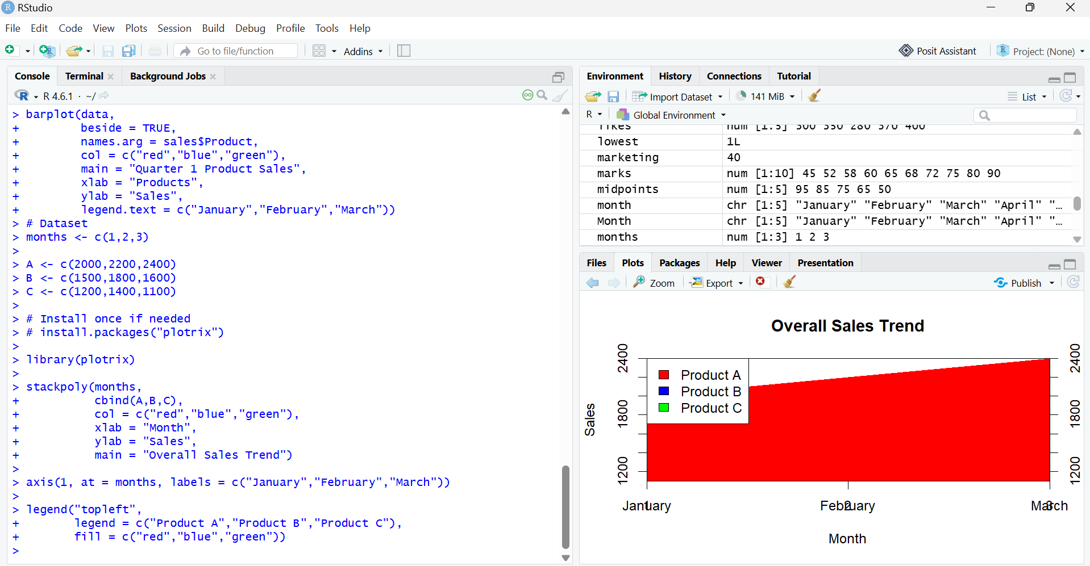

Question 3: Monthly Sales Table
Code:
sales <- data.frame(
Product = c("Product A", "Product B", "Product C"),
January = c(2000,1500,1200),
February = c(2200,1800,1400),
March = c(2400,1600,1100)
)
print(sales)

Output:
